***Wisconsin Conservation Hall of Fame 2019 News***

***Scott Craven, Don Johnson, and***

***Aroline Schmitt to be Inducted***

***on Saturday, April 13th***

***Public is Invited***

**Saturday Afternoon, April 13, 2019**

**SentryWorld (the Atrium) in Stevens Point**

**Program: 12:30 p.m. - Coffee reception (free)**

**2:00 p.m. - Induction Ceremony (free)**

**4:30 p.m. - Dinner – ($25/person)**



**Reservations and Dinner Tickets** available on-line through Eventbrite/WCHF/2019 Induction

[http://bit.ly/WCHF2019Registration](http://bit.ly/WCHF2019Registration" \t "_blank)

or call Schmeeckle Reserve:

715-346-4992.

**More information on WCHF Website**

[www.WCHF.org/](http://www.WCHF.org/)

<https://wchf.org/wchf-announces-2019-inductees/>

**Links to Full News Release (pdf or word):**

<https://wchf.org/1893-2/>

**\_\_\_\_\_\_\_\_\_\_\_\_\_\_\_\_\_\_\_\_\_\_\_\_\_\_\_\_\_\_\_\_\_**

**NEWS RELEASE (1) *Feb 10, 2019***

**Contacts:**

1. Joe Passineau, WCHF Executive Secretary

Email: jpassine@uwsp.edu

Phone: 715-677-4047

**Notes:**

1. This release could be shortened for an informational brief or used, as is, for a longer feature story (published prior to the event or after its completion).

2. For Digital Copy and Photos contact: Joe Passineau at [jpassine@uwsp.edu](mailto:jpassine@uwsp.edu). Please show photo credits.

\_\_\_\_\_\_\_\_\_\_\_\_\_\_\_\_\_\_\_\_\_\_\_\_\_\_\_\_\_\_\_\_\_\_\_\_\_\_\_\_\_

\_\_\_\_\_\_\_\_\_\_\_\_\_\_\_\_\_\_\_\_\_\_\_\_\_\_\_\_\_\_\_\_\_\_\_\_\_\_\_\_\_

***Wisconsin Conservation Hall of Fame***

***– 2019 News –***

The Wisconsin Conservation Hall of Fame (WCHF) will honor three new leaders who have contributed much to Wisconsin’s Conservation Legacy. This year’s ceremony will begin at 12:30 p.m. on Saturday April 13th at SentryWorld (the Atrium) in Stevens Point.

The public is invited.

**The Inductees this year include:**

*(see following pages for photos and full biographies)*

**(1) Scott Craven** – a well-known UW-Madison Wildlife Professor who advanced the public’s understanding and appreciation for Wisconsin’s wildlife and natural resources through his Public Radio Programs, UW-Extension and 4-H Leadership efforts, and projects promoting hunter education and land stewardship.

**(2) Don Johnson** – a popular newspaper columnist for the Milwaukee Sentinel who for over 40 years enlightened readers about Wisconsin’s great outdoors and encouraged them to get involved in key conservation and environmental policies affecting the State’s wildlife, waterways, forests and parklands.

**(3) Aroline Schmitt** – a pioneering woman and citizen conservationist, who worked in a man’s world during the 1930-1960’s to advance sustainable forestry and to promote fledgling conservation organizations and initiatives in Wisconsin and the nation.

**Induction Ceremony Details**

The Induction Ceremony will be held at 2:00 p.m. Saturday, April 13, at SentryWorld (the Atrium) in Stevens Point. A coffee reception at 12:30 p.m. will precede the Ceremony. The Dinner, at 4:30 p.m., is also in the Atrium.

The Induction Ceremony and Coffee Reception are free and open to the public. The Ceremony includes tributes by invited speakers and the presentation of recognition plaques which will be displayed in the WCHF Visitor Center in Schmeeckle Reserve.

Reservations for lunch ($25 per person) may be made online at Eventbrite/ WCHF 2019 Induction Ceremony

<http://bit.ly/WCHF2019Registration>

or by calling Schmeeckle Reserve at 715-346-4992.

**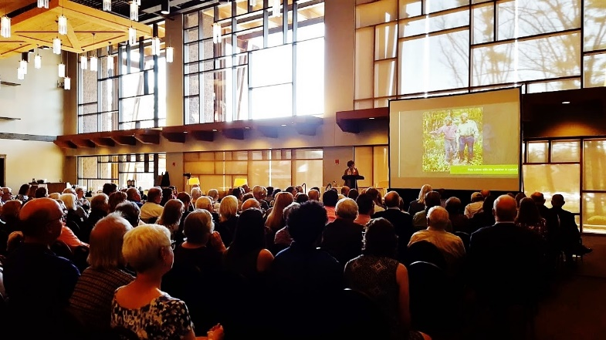**

*Photo by J. Passineau*

**WCHF 2018 Induction Ceremony at SentryWorld**

**Quotes by WCHF President**

**The Wisconsin Conservation Hall of Fame**

The Wisconsin Conservation Hall of Fame and Visitor Center is located at Schmeeckle Reserve in Stevens Point. It was established in 1985 to advance the conservation legacy of Wisconsin and now recognizes nearly 100 leaders who have contributed significantly to it.

Individuals may be nominated for induction by member organizations or by the public. Based on a set of criteria, nominees are selected for induction by the WCHF Board of Directors and an independent Board of Governors.

The WCHF and Schmeeckle Visitor Center includes:

(a) a sunlit gallery displaying recognition plaques of the inductees,

(b) a meeting/classroom used by hundreds of civic organizations each year, and (c) an interpretive display museum illustrating the full story of conservation in Wisconsin. Each year thousands of visitors also enjoy the beautiful landscapes, hiking trails, educational programs and gift shop at Schmeeckle Reserve.

WCHF is a cooperative venture of 35 state-wide conservation organizations. WCHF depends on the generous support of member organizations, affiliate members, grants and donations.

For membership information see: [www.wchf.org](http://www.wchf.org) . Or to join, see the on-line Eventbrite Ticket option: <http://bit.ly/WCHF2019Registration>

Reflecting on this year’s ceremony,

WCHF President, Michael John Jaeger, said:

“The Inductees this year again reflect the diverse legacy of conservation in Wisconsin. The inductees include (1) a popular radio celebrity and UW-Madison Professor of Wildlife, (2) a much- loved outdoors writer and Milwaukee Sentinel columnist, and (3) a pioneering woman, with health disabilities, who championed Forest Conservation while working in a man’s world in the 1940’s.

Jaeger added: “With the addition of our three new inductees, the Wisconsin Conservation Hall of Fame now recognizes 99 men and women who have dedicated their lives to the advancement of Wisconsin’s Conservation Legacy. Through their personal and professional efforts, dedication, and love for nature, they have changed the world.”

He also noted, “The Induction Celebration this year will be held on Saturday afternoon in the beautiful sunny Atrium at SentryWorld. All are invited to help us celebrate our newest inductees!”

**Inductee Biographies**

**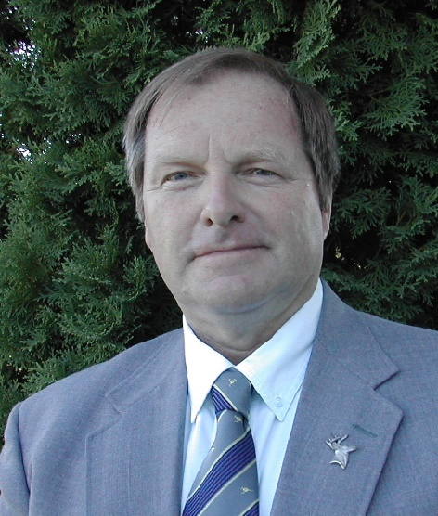**

***Photo Credit: Candee Craven***

**Scott Craven (1948 - )**

Scott Craven is an ambassador for Wisconsin’s wildlife, with a gift of sharing his knowledge and enthusiasm for Wisconsin’s natural resources. As a popular UW- Madison Wildlife Professor, he reached thousands through his UW-Extension presentations, publications, and programs on wildlife, natural resources, and the land ethic.

He also found a niche in public education through public radio and other prominent media outlets. As a gifted speaker, he has a unique way of captivating his audience with facts, stories and humor. He has helped educate the public on how to attract wildlife and how to thoughtfully deal with nuisance wildlife and wildlife damage. Scott also provided service and leadership to hundreds of agencies and organizations, and to thousands of private home and land owners, through his selfless contributions of time and effort.

His time in Wisconsin started in 1972 as a graduate student at the University of Wisconsin-Madison in the Department of Wildlife Ecology, continuing for more than 40 years as a Professor, Extension Wildlife Specialist, and Department Chair. He was an advisor and mentor to hundreds of undergraduate and graduate students through classes, internships and independent study projects. He also advanced youth education in Wisconsin through his 4-H leadership efforts and hunter education programs.

Scott Craven has been one of the most influential conservation educators in Wisconsin in the last half century. Since his retirement Scott has continued to be a committed conservationist and prolific ambassador for wildlife. He is known and respected in virtually every corner of the state and has received numerous awards for his contributions to conservation from many organizations, agencies, and universities including The Wildlife Society, UW- Madison and UW-Extension, Wisconsin 4-H, USDA -Wildlife Services, and the Wildlife Management Institute.

**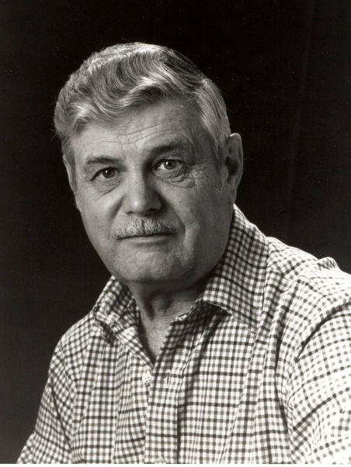**

***Photo Credit: Milwaukee Journal Sentinel***

**2. Don L. Johnson (1927 - 2006)**

For a period spanning more than four decades, Don L. Johnson was one of Wisconsin’s best-known outdoor writers and columnists. He wrote extensively about hunting and fishing in Wisconsin, first for the *Eau Claire Leader and Telegram* and then for the *Milwaukee Sentinel*. But he also tackled complex public policy issues affecting the state’s natural resources including wildlife management, preservation of wildlands, and the regulation of environmental pollution. He became a major educator of the public during a critical period in the development of conservation advocacy and government regulatory policy.

Johnson was a pioneer in environmental journalism, responsible for groundbreaking and influential reporting on issues as diverse as environmental contamination by DDT and other chlorinated hydrocarbons, mercury pollution in state waterways, and harm done to waterfowl by use of lead shot. Don’s reporting contributed to positive changes in public policy, with longer-term benefits to Wisconsin’s natural heritage.

**Continued (Inductee Biographies)**

With a love of nature and conservation, Don Johnson received his degree in journalism and biology in 1951 from the University of Wisconsin-Madison. In addition to his work with newspapers, Johnson was widely published as a freelance writer in many outdoor-oriented publications. He wrote a series of short nature essays in the *Sentinel* which were published in book form in 2005 as *Summer’s Song and Other Essays*.

In addition to his journalism, he was an avid outdoorsman and was involved in public education pertaining to outdoor-related activities, promoted a wide-variety of outdoor sports, conducted workshops and clinics, and helped design the state’s first hunter-safety program. Through his writings and service, he also advanced the efforts and mission of many conservation-oriented organizations, including the Wisconsin Conservation Hall of Fame.

For his service and exemplary writing, he received many honors from conservation, environmental and outdoor organizations, including the Gordon MacQuarrie Award, and other awards from the Wisconsin Wildlife Federation, the Wisconsin Natural Resources Board, the EPA, and the Outdoor Writers Association of America.

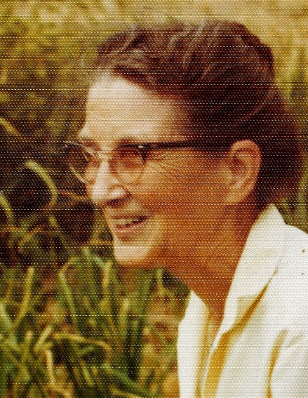

***Photo Credit: Maxine Schmitt Roberts***

**3. Aroline Schmitt (1904 - 1995)**

Aroline Schmitt is a good example of how women have been instrumental in leading citizen conservation crusades in Wisconsin and the nation. During the 1940 to the 1960’s, she advanced the principles and practice of sustainable forestry, organized and led new conservation organizations, and worked hand in hand with many other conservation leaders. Despite health challenges, she fought with tenacity and charisma to advance major conservation policies affecting Wisconsin’s natural heritage.

She became a passionate champion for “Forest Conservation” at both the State and national level. Trained as a nurse, she began her conservation work during World War II in what was then a man’s world, surveying and cruising timber lands for the US Forest Service in Alaska and the west. She continued in various roles with the Forest Service until 1961. She promoted the principles of sustainable forestry and timber management, before the practice was known by that name. She always prodded politicians, conservationists and industrial foresters to adopt good forestry practices. Working with Gifford Pinchot (former Director of the U.S. Forest Service) and others, she also helped establish and leda national conservation organization called “Forests.”

Her Wisconsin conservation efforts occurred from the 1930s to the 1960s. A frequent speaker and advocate for strong resource policy, she was a prolific letter writer and traveled the state to participant in important meetings and legislative hearings. She worked arm-in-arm with conservation luminaries including Aldo Leopold, William Aberg, and Wilhelmine La Budde. She also helped to organize and lead the Citizens Natural Resources Association and the conservation programs of the Wisconsin Garden Club Federation.

She also played a pivotal role in protecting the Flambeau State Forest, the Menominee Tribal Forest, and the creation of Trees for Tomorrow and the Northern Forest Research Center. She was recognized for her exemplary conservation work by the Citizens Natural Resources Association (Silver Acorn Award, 1961), the Wisconsin Garden Club Federation (1956), and the Izaak Walton League (Broughton Award, 1950).

For many years, due to persistent health problems, she fought her conservation battles from her bed and home office. With tenacity and dedication, she continued to influence conservation policy through her telephone calls, writings, and personal charisma.

**\_\_\_\_\_\_\_\_\_\_\_\_\_\_\_\_\_\_\_\_\_\_\_\_\_\_\_\_\_\_\_\_\_\_\_\_\_\_\_**

***END OF WCHF 2019 NEWS RELEASE***

**Contact** [**jpassine@uwsp.edu**](mailto:jpassine@uwsp.edu) **for digital photos of inductees.**